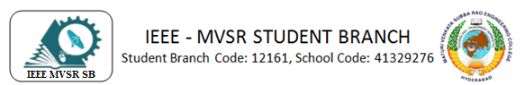

Professional Development Program on SCILAB
IEEE MVSR PES Student Chapter, in collaboration with Spoken-Tutorial, Ministry of Human Resources and Development, Government of India, had conducted a Professional Development Program on SCILAB on 7th December 2019.

Student Branch Mentor:

Dr. Atul Negi,
Professor, School of CIS,
University of Hyderabad.

Student Branch Advisor:

Mr. V. Ashwini Kumar, Assoc. Professor, IT Dept., MVSR Engineering College.

PES Advisor:
Dr. D. Hari Krishna,
Assoc. Professor, EEE Dept.,
MVSR Engineering College.

Students Branch Executive Committee:

R. Ramyasri - Chairperson
K. Akshitha - Vice Chair
M. Shreya - Secretary
K. Vinay Kumar - Joint Secretary
V. Vineeth - Treasurer
P. Varun Kumar-Operating Committee Head

Computer Society:
S. Sai Teja - Chair
G. Suradhya - Vice Chair
M. VamsiKrishna - Secretary
A. Phani Sahasra - Joint Secretary

V. Manikanta- Treasurer

Circuits and Systems Society:
D.Siddartha -Chair
K.Jaideep -Vice Chair
D.V.B Parthiv -Secretary
D.Venkat -Joint Secretary
P.Shravya -Treasurer
WIE Student Branch Advisor:

Mrs. Dr. G. Kanaka Durga,
Principal,
MVSR Engineering College.

Student Branch Counsellor:

Dr. D. Hari Krishna,
Assoc. Professor, EEE Dept.,
MVSR Engineering College.

CS student branch advisor:
Mrs. B. Saritha
Assoc. Professor, CSE Dept.,
MVSR Engineering College

CASS Student Branch Advisor:
Mrs. S. Aruna
Asst. Professor, ECE Dept.,

MVSR Engineering College.

WIE Affinity Group:

A. Sai Pratyusha - Chairman
M. Shresta - Vice Chair
Sahithya Namani - Secretary

L. Ruthvika - Joint Secretary
R. Ruchitha - Treasurer

Power Energy Society:
E. PavanKumar - Chair
Jayasree K - Vice Chair

N. Avinash - Secretary
B.Nikita Reddy - Joint Secretary

S. Satvika - Treasurer

Operating Committees:
Ch. Jinesh- Publicity Committee
M.V.S.S.S.R Sahith-Membership Committee
Hemish& Y. Sai Sameer - Design Committee

M. Sai Sri Teja- Program Committee
Session details:
Date : 7th December, 2019
Time : 9.30 am–1.30 pm.
Venue: QEEE Room, EEE Department, MVSREC.

Agenda:
Introduction to SCILAB
How to get and install SCILAB
How to get help in SCILAB
Explanation on
- Basic elements of the language
- Comparison operators
- Matrices
- Looping and Branching
- Functions

The Professional Development Program on SCILab started with the introduction of speaker Mr. N. Bharat Mohan, Assistant Professor, EEED to the participants by Mr. E. Pavan Kumar, IEEE MVSR SB PES Chair.

Mr. N. Bharat Mohan delivered his lecture on SCILAB starting from installation process and then basic commands of the SCILAB software. He continued his session with comparison operators, matrices, looping and branching functions used in SCILAB. At the end of theoretical session Mr. N. Bharat Mohan has interacted with participants and clarify their doubts.

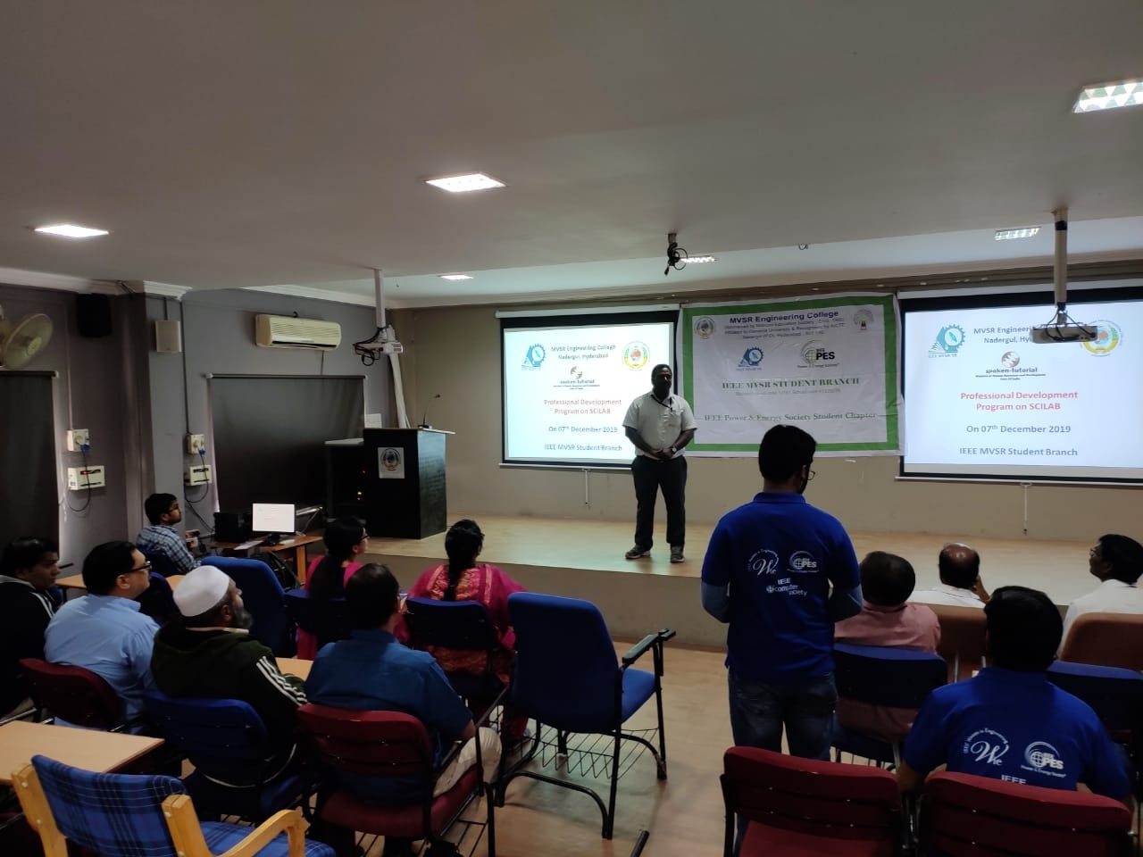
Mr. N. Bharat Mohan delivering lecture on SCILAB

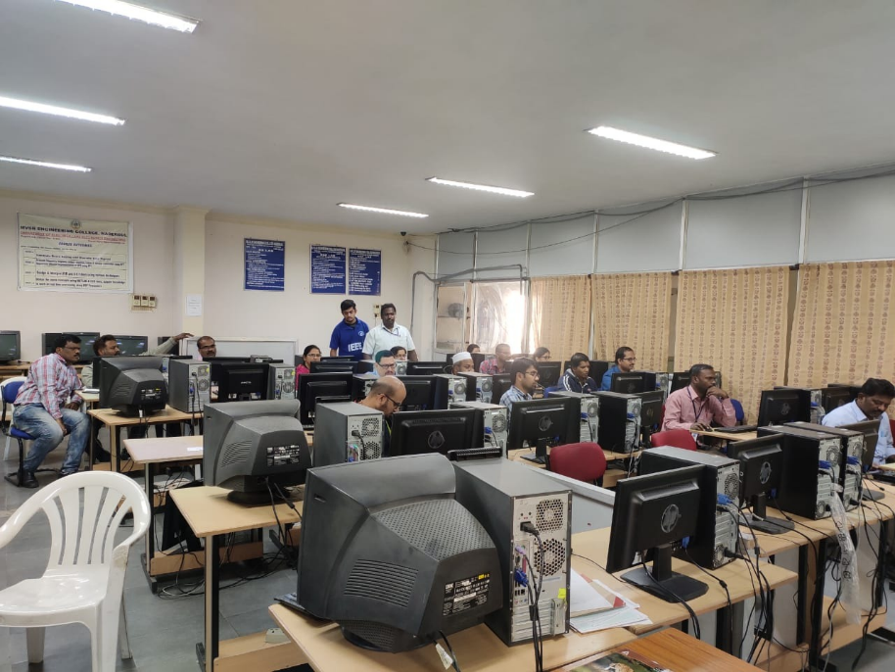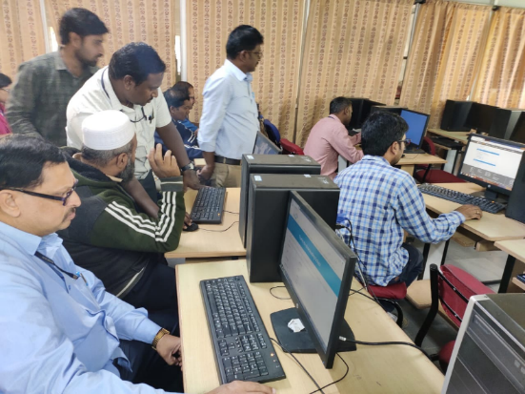
Hands on Session in simulation lab to the participants

After a small break the next session continued with hands-on experience with SCILAB software environment in Simulation Lab. All the participants have practiced various SCILAB commands and tasks given by Mr. N. Bharat Mohan.

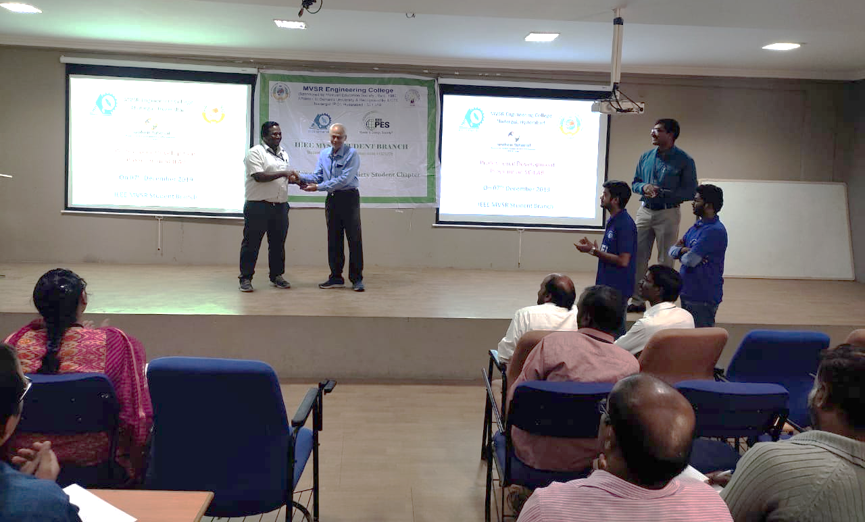
Mr. C.V. Gopala Krishna. Rao, Head EEED presenting memento to Mr. N. Bharat Mohan

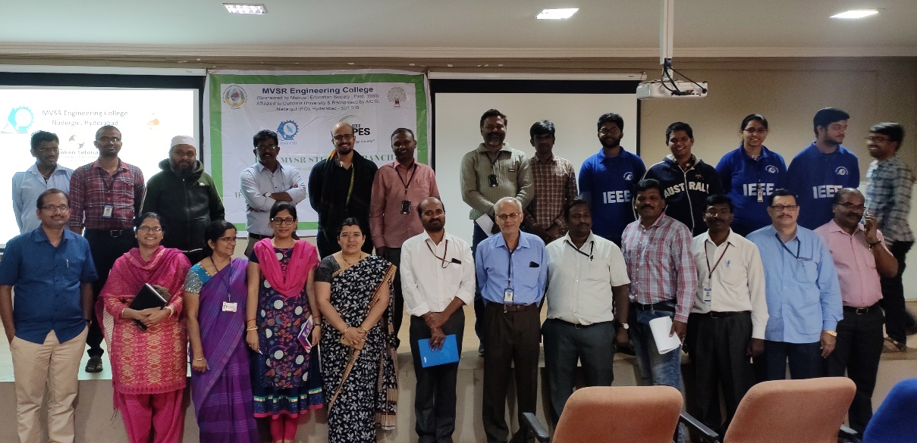
Group photo

The professional development program on SCILAB was concluded by presenting a memento to Mr. N. Bharat Mohan by Mr. C.V. Gopala Krishna. Rao, Head EEED and vote of thanks by Dr. D. Hari Krishna, IEEE MVSR SB-PES Advisor.

Reported by:
IEEE MVSR SB.

